PROG6221 PART 1

ST10066258

Tshedza Ramabulana

2023

Table of Contents

Link to GitHub respiratory 2

Screenshot 2

Readme 2

Video of POE PART 1 3

# Link to GitHub respiratory

<https://github.com/IIEMSA/prog6221-part1-Tshedza2001>

<https://github.com/IIEMSA/prog6221-part1-Tshedza2001/releases/tag/prog6221-part1>

# Screenshot

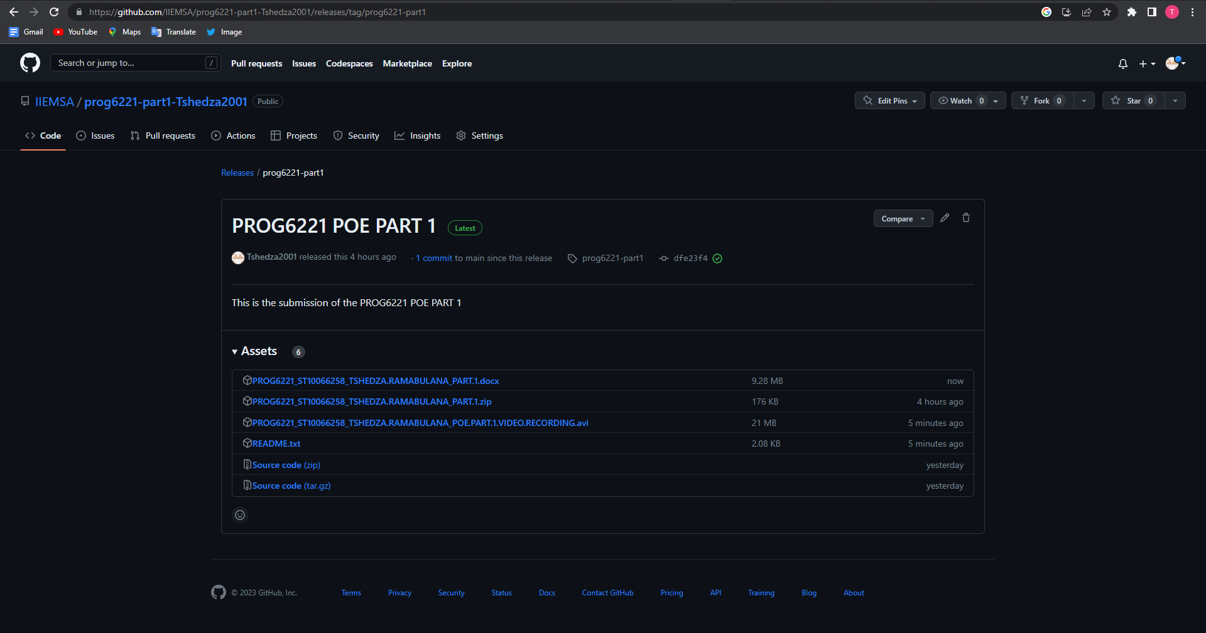

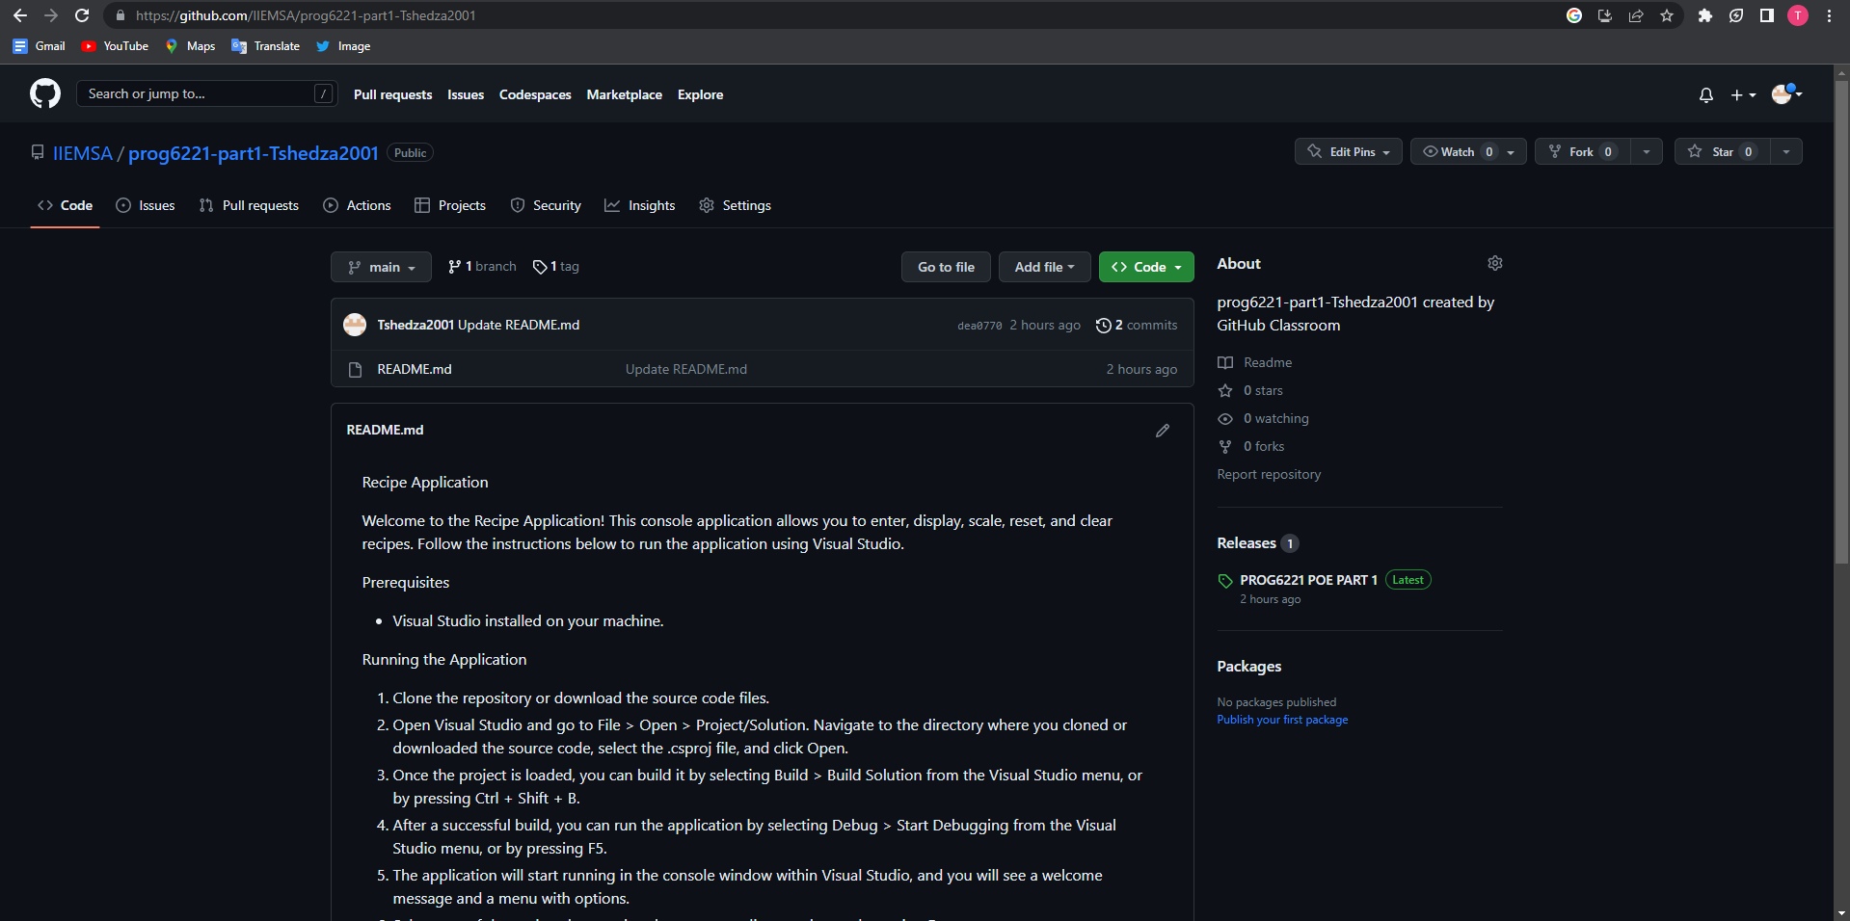

# Readme



# Video of POE PART 1

